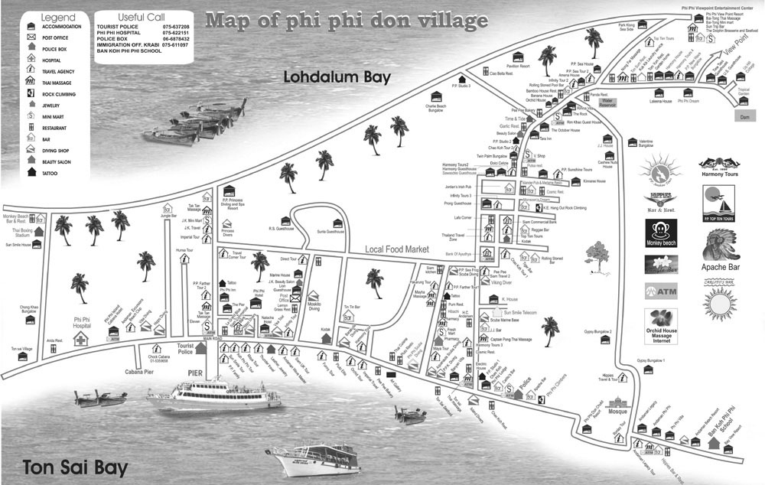
Tonsai Village before tsunami
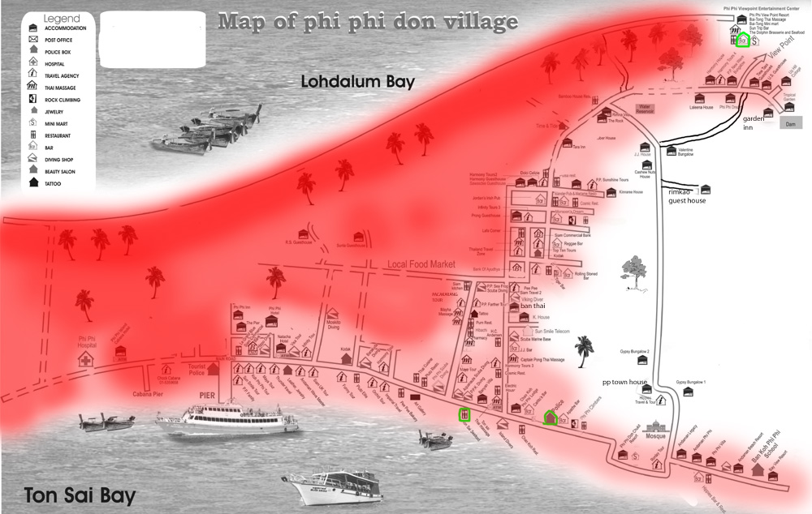
Tonsai Village after tsunami
Areas in dark red indicate total destruction; light red partial destruction or severe flooding

